Source ID – 77194799

Source Title -Rivista Italiana di Paleontologia e Stratigrafia

URL -https://riviste.unimi.it/index.php/RIPS/issue/archive

1. Go to the URL and current issues in the website.

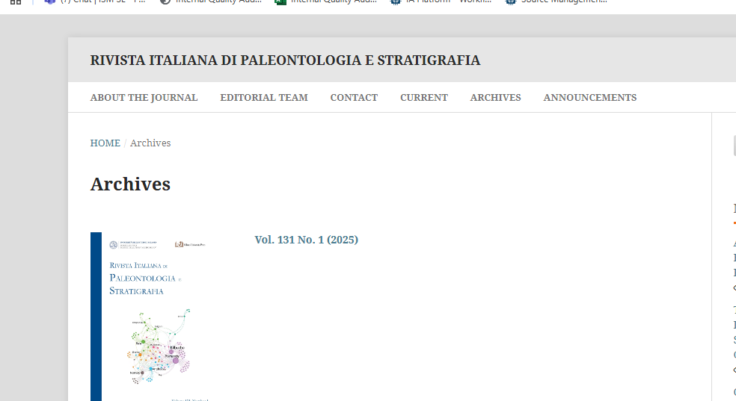

Select the current issue

2.Capure the mata data as shown below.

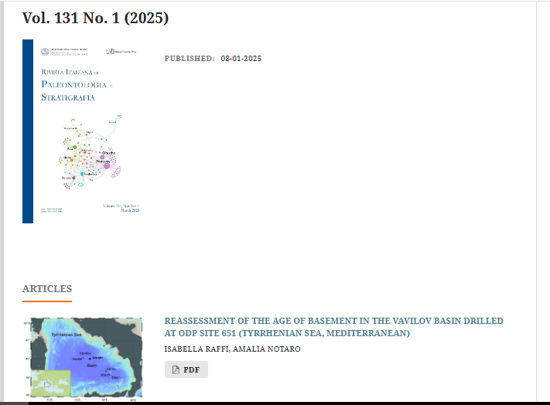

Article title

Year

Issue

Volume

PDF

3. Click the article title to capture to DOI.

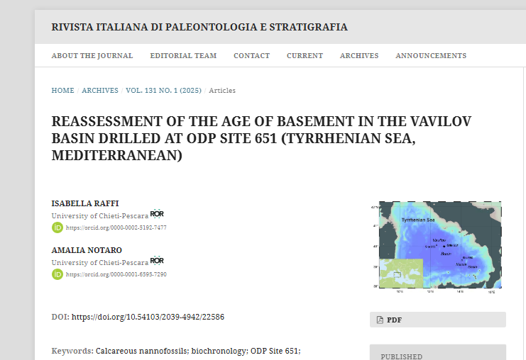

DOI

4. Clicking the PDF will direct you to the PDF viewer page.

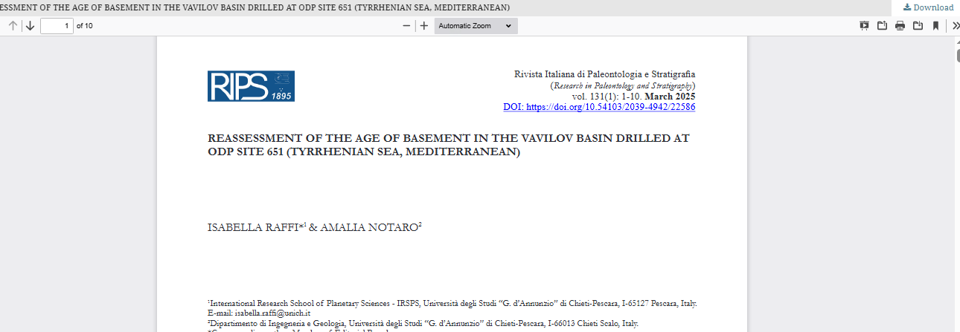

Click to the download PDF